**DÖNEM PROJESİ ÖNERİSİ**  
*210313024 Hasan Berk SELÇUK*

**Proje Başlığı:**

Scouting Database Management System

**Proje Senaryosu:**

**It is the database system used to scouting the transfer of Teams around the world.**

**Proje Bileşenleri:**

1. **Entities:**

* **Players Table**
* **Countries Table**
* **Teams Table**
* **Leagues Table**
* **Matches Table**
* **Transfers Table**
* **Coaches Table**
* **Stadiums Table**
* **Injuries Table**
* **PlayerProfiles Table**
* **PlayerStats Table**
* **Awards Table**

1. **Relationship:**

* **Players** to **Countries** (many-to-one)
* **Players** to **Teams** (many-to-one)
* **Players** to **PlayerProfiles** (one-to-one)
* **Teams** to **Leagues** (many-to-one)
* **Leagues** to **Countries** (many-to-one)
* **Matches** to **Teams** (many-to-one for home and away)
* **Players** to **PlayerStats** (one-to-many)
* **Players** to **Transfers** (one-to-many)
* **Teams** to **Coaches** (one-to-many)
* **Teams** to **Stadiums** (one-to-many)
* **Players** to **Injuries** (one-to-many)
* **Players** to **Awards** (one-to-many)

1. **Attribute:**

* **Players Table = PlayerID** (Primary Key), **FirstName, LastName, Age, Nationality**, **TeamID** (Foreign Key), **Position, Height, Weight, DateOfBirth, MarketValue**
* **Countries Table = CountryID** (Primary Key), **CountryName**, **Continent**
* **Teams Table = TeamID** (Primary Key), **TeamName**, **LeagueID** (Foreign Key), **CountryID** (Foreign Key), **FoundedYear**, **StadiumName**, **ClubColors**
* **Leagues Table = LeagueID** (Primary Key), **LeagueName**, **CountryID** (Foreign Key), **Tier**
* **Matches Table = MatchID** (Primary Key), **Date**, **HomeTeamID** (Foreign Key), **AwayTeamID** (Foreign Key), **Score**, **LeagueID** (Foreign Key)
* **Transfers Table = TransferID** (Primary Key), **PlayerID** (Foreign Key), **FromTeamID** (Foreign Key), **ToTeamID** (Foreign Key), **TransferDate**, **TransferFee**
* **Coaches Table = CoachID** (Primary Key), **FirstName**, **LastName**, **TeamID** (Foreign Key), **Nationality, DateOfBirth**
* **Stadiums Table = StadiumID** (Primary Key), **StadiumName**, **Capacity**, **Location**, **TeamID** (Foreign Key)
* **PlayerProfiles Table = ProfileID** (Primary Key), **PlayerID** (Foreign Key, Unique), **Biography**, **TwitterHandle**, **InstagramHandle**, **Website**
* **PlayerStats Table = StatID** (Primary Key),**PlayerID** (Foreign Key), **MatchID** (Foreign Key), **Goals**, **Assists**, **YellowCards**, **RedCards**, **MinutesPlayed**
* **Awards Table = AwardID** (Primary Key), **PlayerID** (Foreign Key), **AwardName**, **Year**
* **Injuries Table = InjuryID** (Primary Key)**PlayerID** (Foreign Key), **InjuryType**, **StartDate**, **EndDate**

**4. Existence Dependency:**

"In relation to the Players table, each player will have an ID (PlayerID), first name (FirstName), last name (LastName), age (Age), date of birth (DateOfBirth), and market value (MarketValue) information. However, each player must belong to a team (TeamID) and a country (CountryID)."

**5. ISA Relationship:**

ISA (Inheritance) relationship can be applied between Players and Coaches. Both entities represent individuals with similar attributes like FirstName, LastName, and DateOfBirth, but they serve different roles in the system.

**6. Exclusion:**

We can define an exclusion relationship between Players and Coaches.

"An entity that is classified as a Player cannot simultaneously be classified as a Coach and vice versa. In other words, a person must either be in the Player subclass or the Coach subclass, but not in both."

This exclusion ensures that one individual cannot hold both roles within the system at the same time.

**7. Weak Entity:**

In my schema, the PlayerStats table can be considered a weak entity. This is because the existence of PlayerStats depends entirely on both the Players and Matches entities. Without a player or a match, the player’s statistics would have no meaning.

**8. Disjoint:**

The disjoint relationship can be defined between the Players and Coaches entity classes.

"The Players and Coaches entity classes are disjoint, meaning that an individual cannot be classified as both a Player and a Coach simultaneously. "

.**9. Overlapping:**

An overlapping relationship can be established between the Players and Coaches entity classes in certain scenarios:

"The Players and Coaches entity classes may exhibit an overlapping relationship, meaning that an individual could be classified as both a Player and a Coach at different times or under specific conditions (for example a retired player taking on a coaching role)."

**10. Relationship Diagram:**

* **Players**(PlayerID, FirstName, LastName, Age, TeamID (FK), Position, Nationality, Height, Weight, DateOfBirth, MarketValue)
* **Countries**(CountryID, CountryName, Continent)
* **Teams**(TeamID, TeamName, LeagueID (FK), CountryID (FK), FoundedYear, Stadium, ClubColors)
* **Leagues**(LeagueID, LeagueName, CountryID (FK), Tier, FoundedYear)
* **Matches**(MatchID, Date, HomeTeamID (FK), AwayTeamID (FK), Score, LeagueID (FK))
* **PlayerStats**(StatID, PlayerID (FK), MatchID (FK), Goals, Assists, YellowCards, RedCards, MinutesPlayed)
* **Transfers**(TransferID, PlayerID (FK), FromTeamID (FK), ToTeamID (FK), TransferDate, TransferFee)
* **Coaches**(CoachID, FirstName, LastName, TeamID (FK), Nationality, DateOfBirth)
* **Stadiums**(StadiumID, StadiumName, Capacity, Location, TeamID (FK))
* **Injuries**(InjuryID, PlayerID (FK), InjuryType, StartDate, EndDate, Severity)
* **PlayerProfiles**(ProfileID, PlayerID (FK, Unique), Biography, TwitterHandle, InstagramHandle, Website)
* **Awards**(AwardID, PlayerID (FK), AwardName, Year)

**E-R (Chen) Diagramı:**

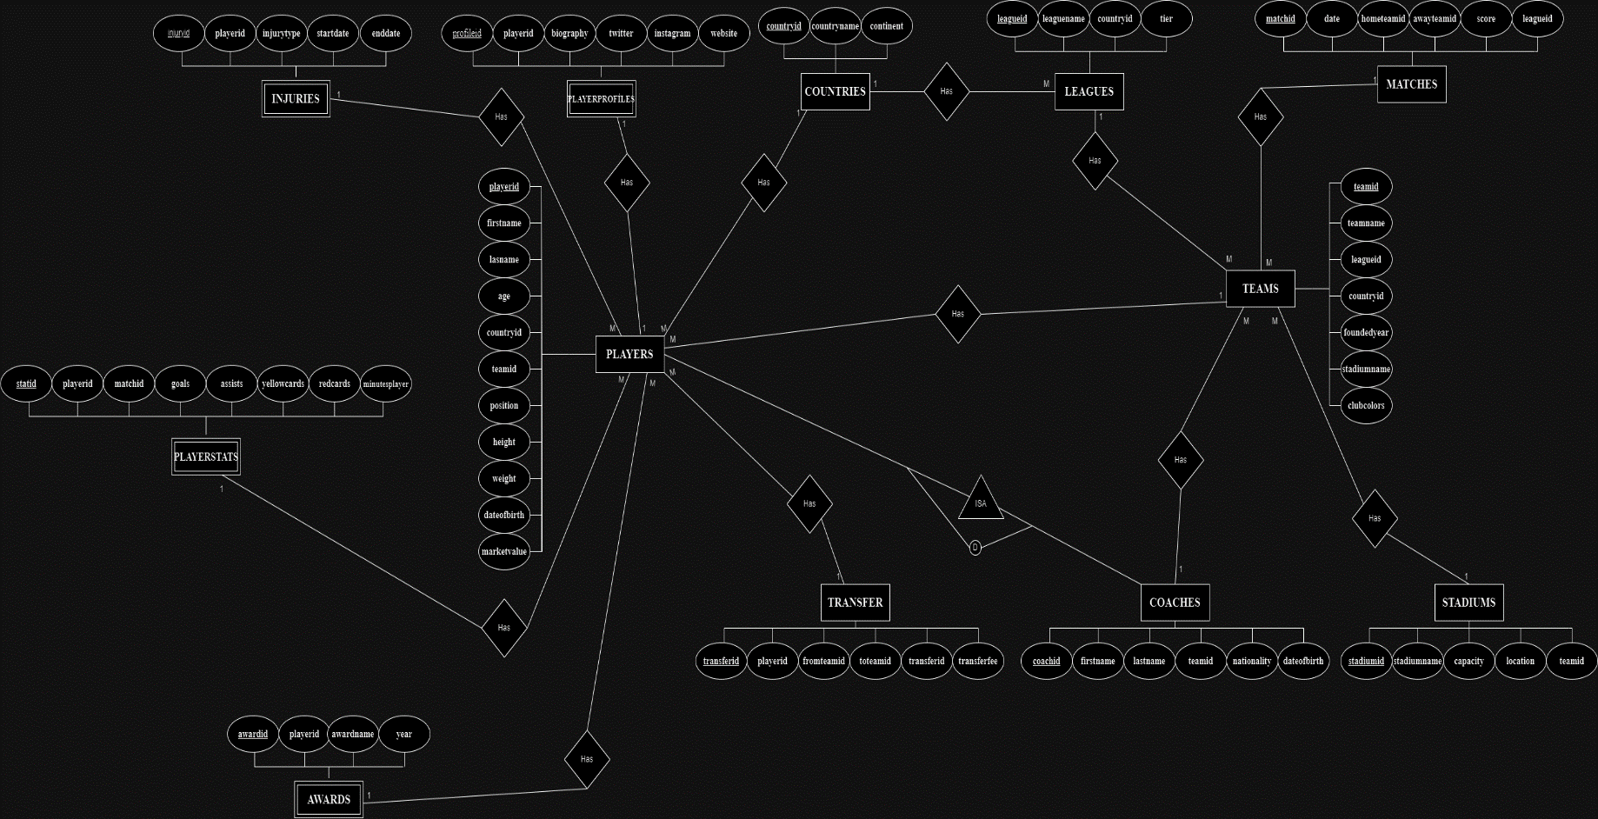

[DRAW.IO LINK](https://app.diagrams.net/#G1G2_uh_u5FhDb10uQZ88peFIkho4vvNEL)

**Değerlendirici Görüşü:** The project has the potential to have a broad widespread impact on its target audience. It can be effective in covering all relevant stakeholders, not just a specific sector. In addition, it is expected that this project will make an economic contribution in the long term and add value to the relevant sector. The focus of the project offers an innovative solution proposal that will meet current needs.